# **Dusk Test Report**

This report contains screenshots of total 15 test cases carried out.

GitHub Link: <https://github.com/vinisha99/FAQDusk.git>

Heroku Link: <https://faq-dusk.herokuapp.com/>

1. Test to Register User:

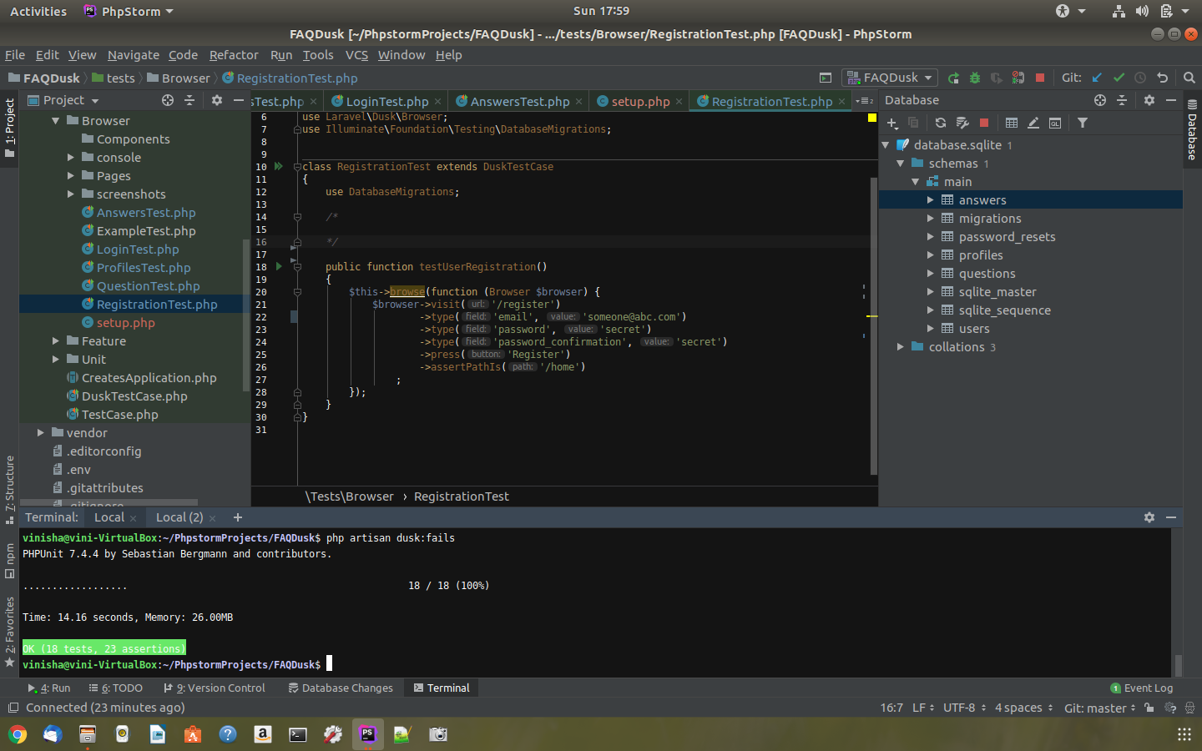

1. Test For User Login:

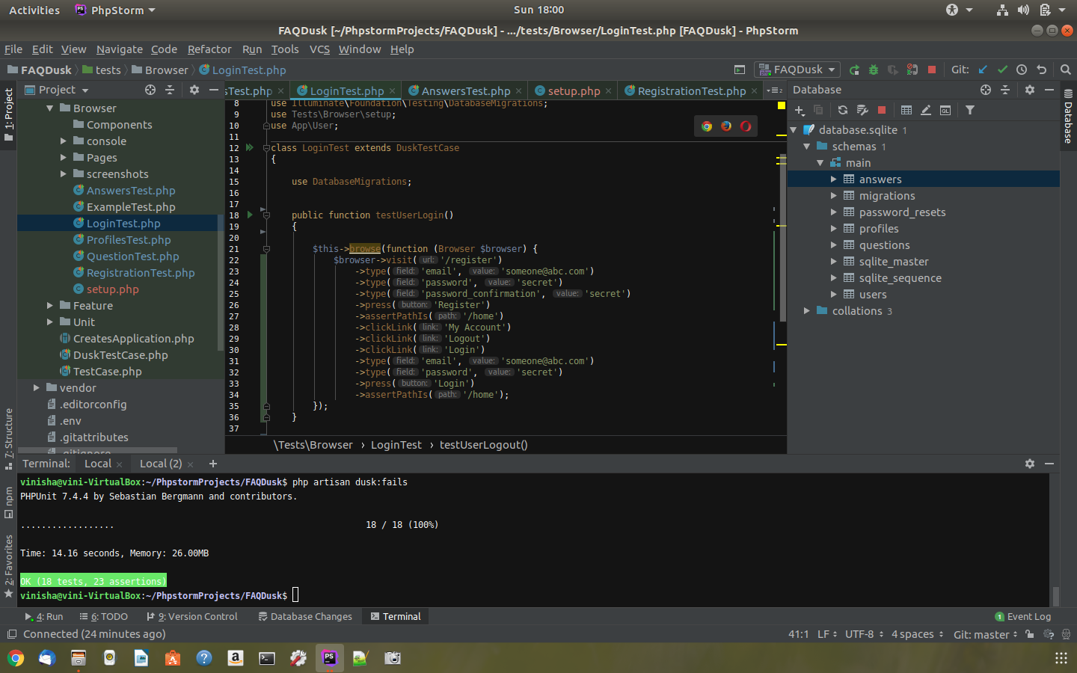

1. Test for User Logout

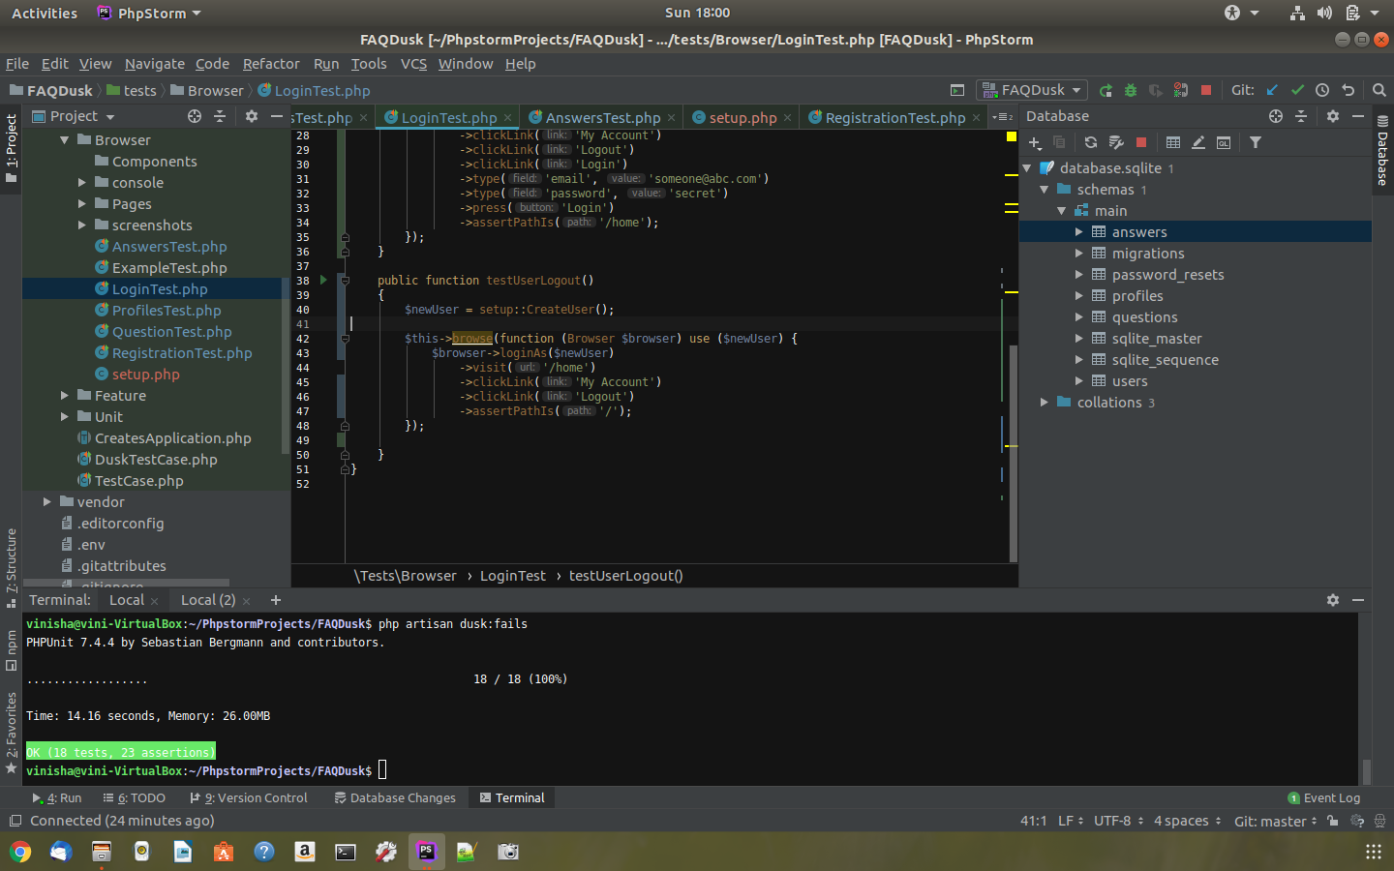

1. Test to create Profile for user:

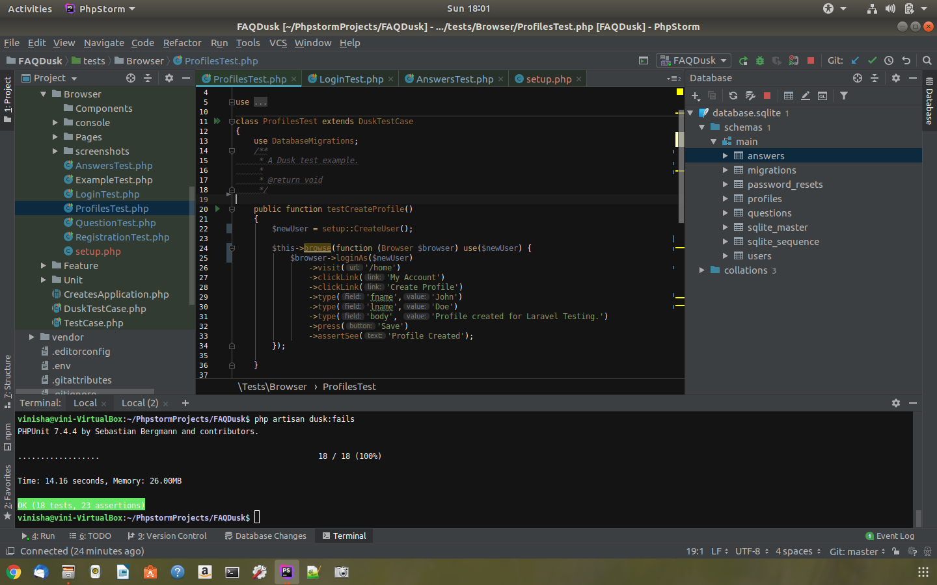

1. Test to view created Profile:

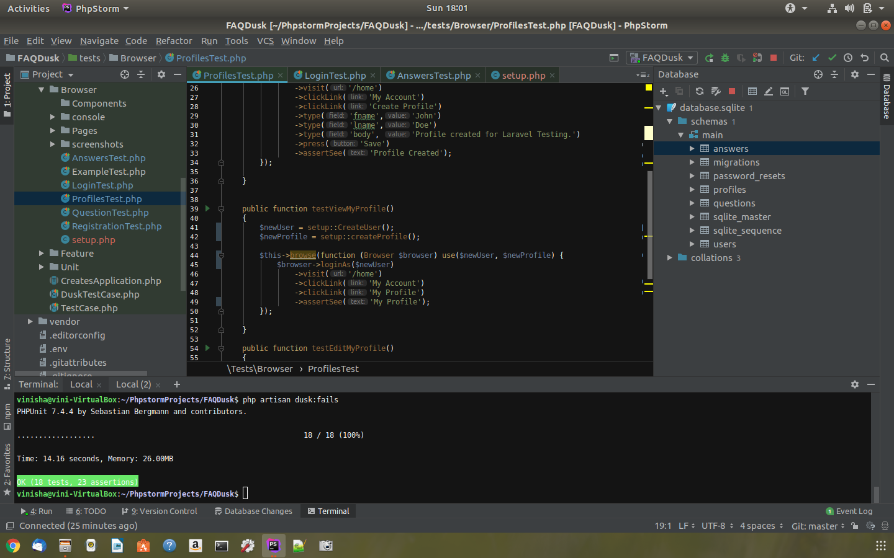

1. Test to Edit Profile:

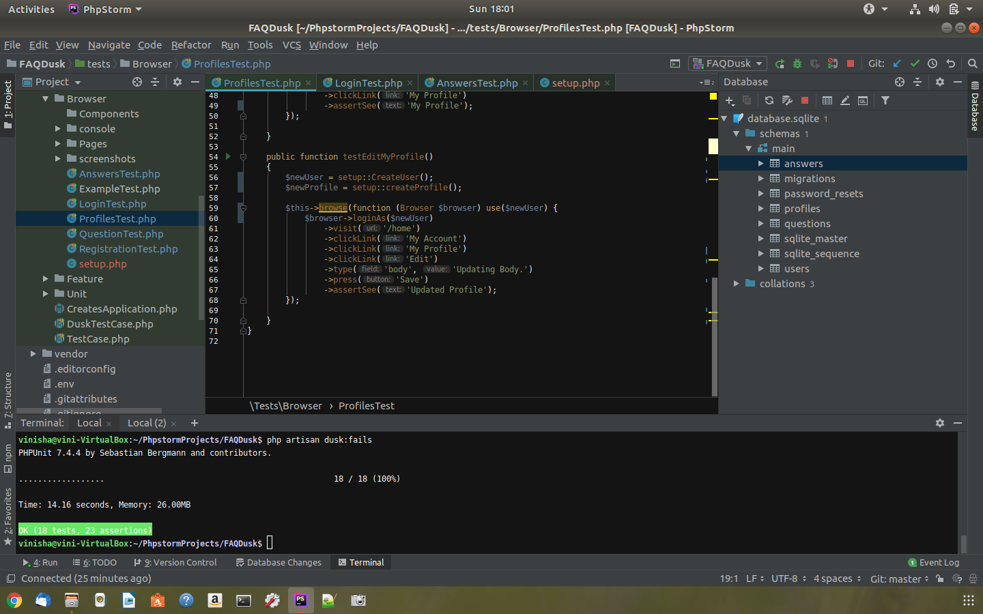

1. Test to Create a new Question

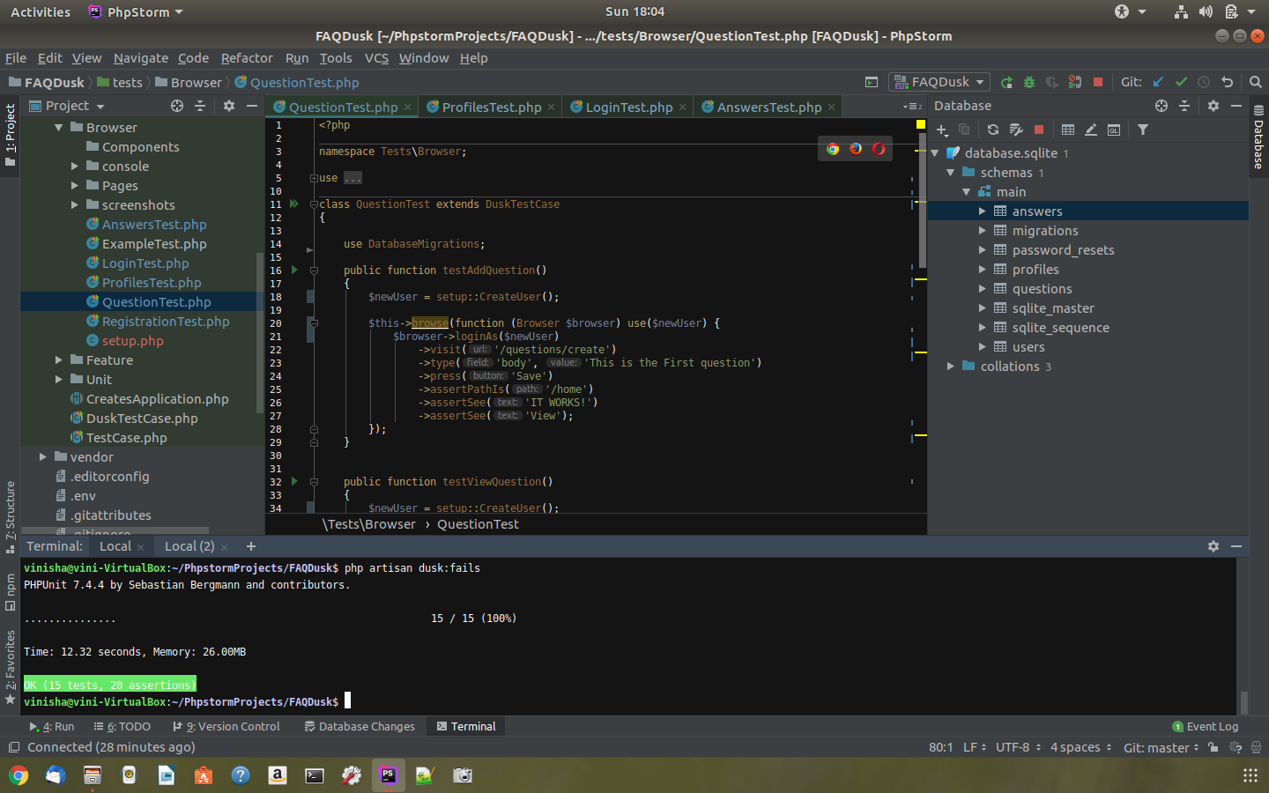

1. Test To View Added Question:

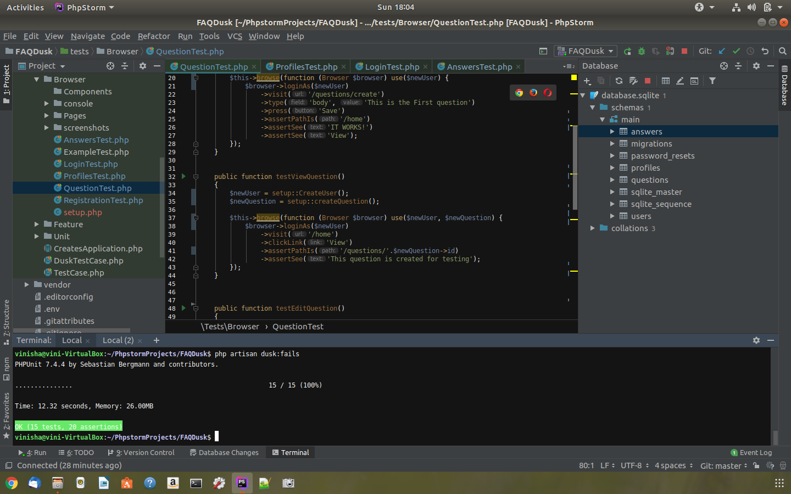

1. Test to Edit Question:

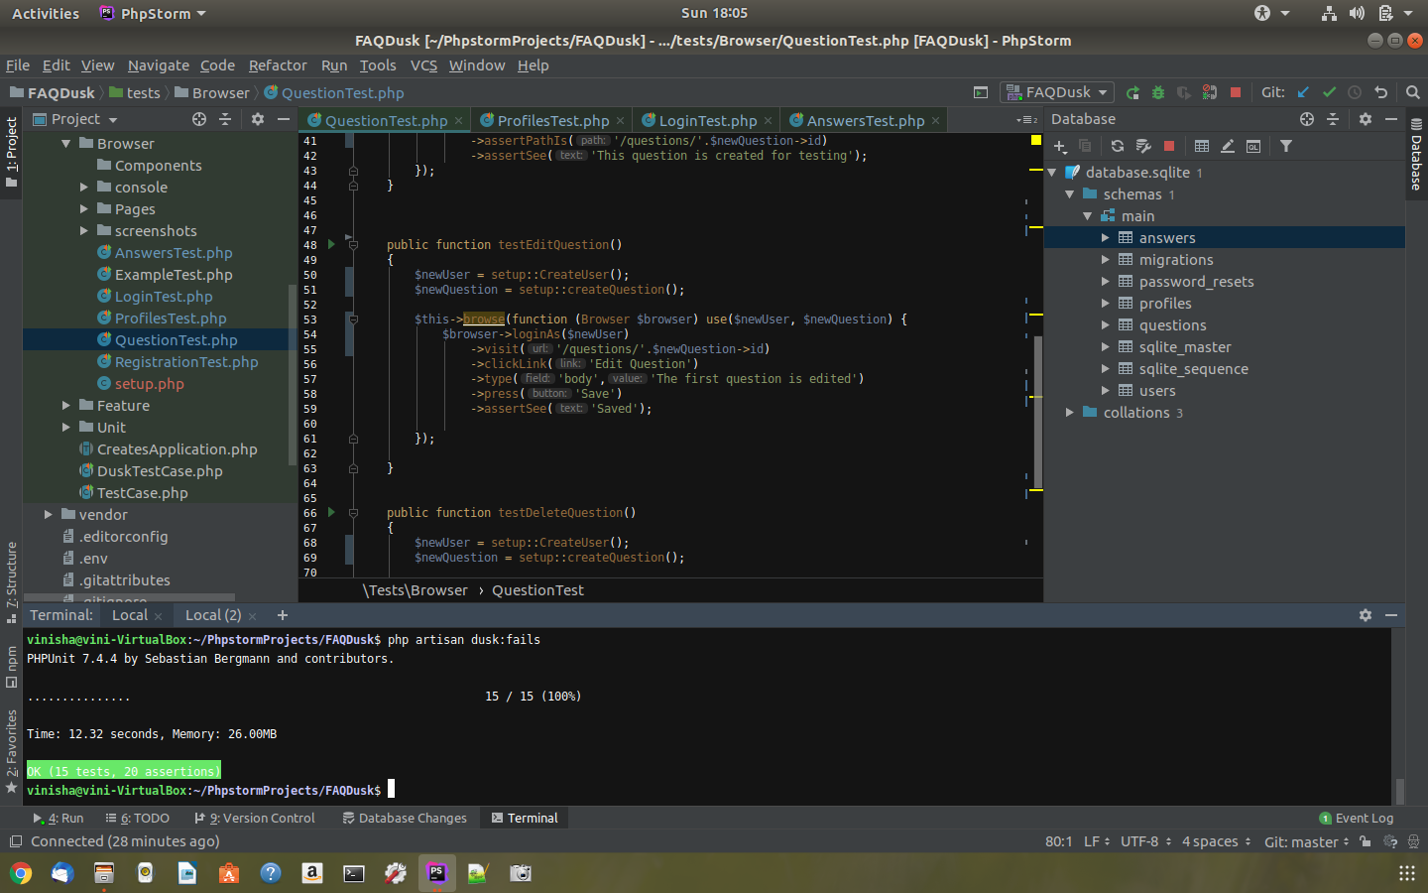

1. Test to delete Question:

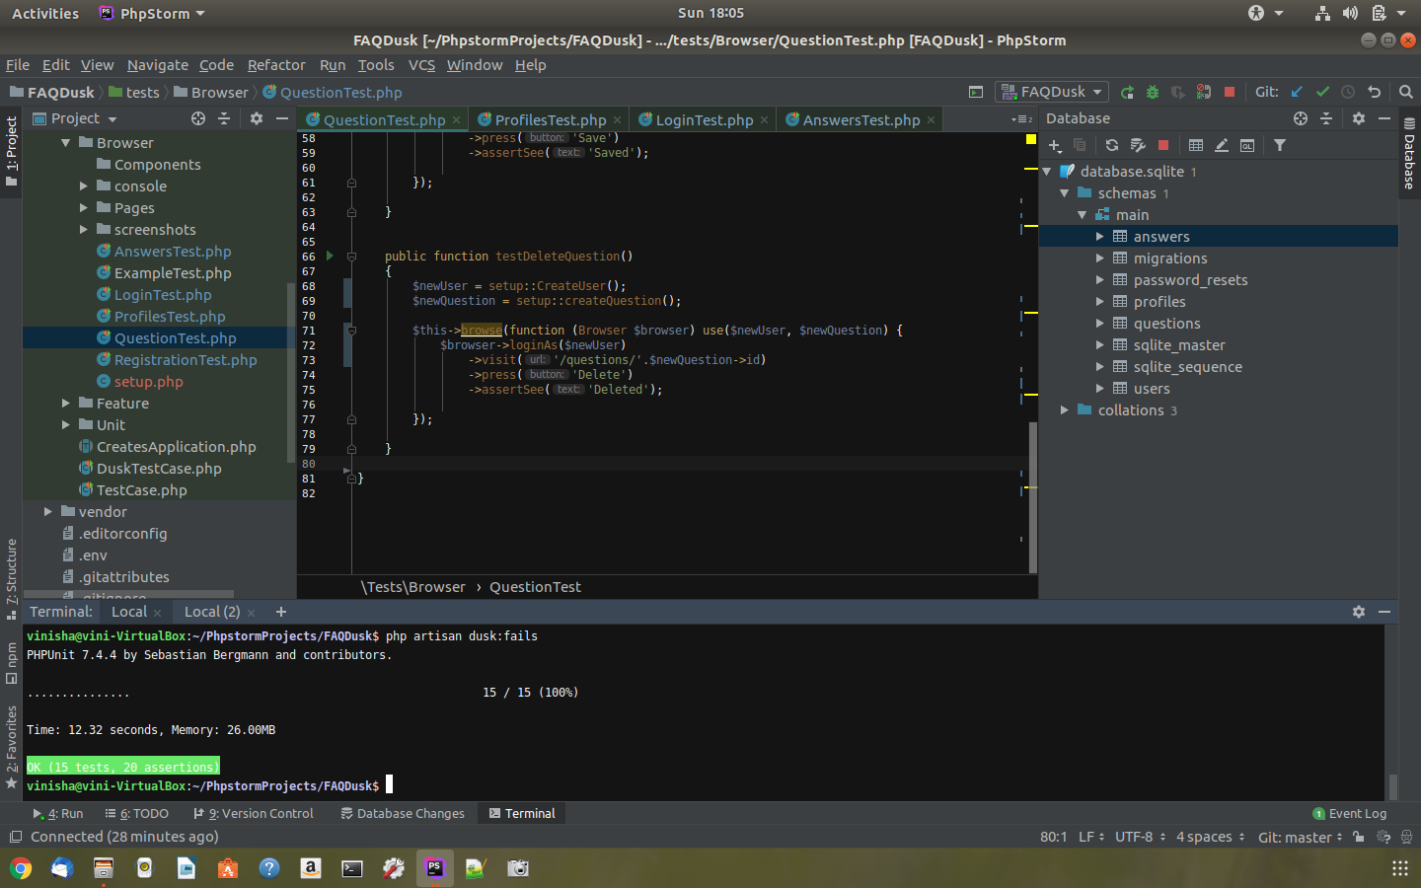

1. Test to Add Answers:

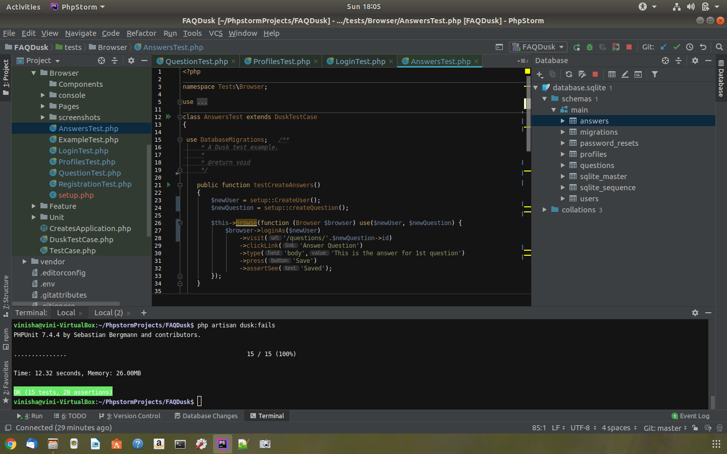

1. Test to View Answer:

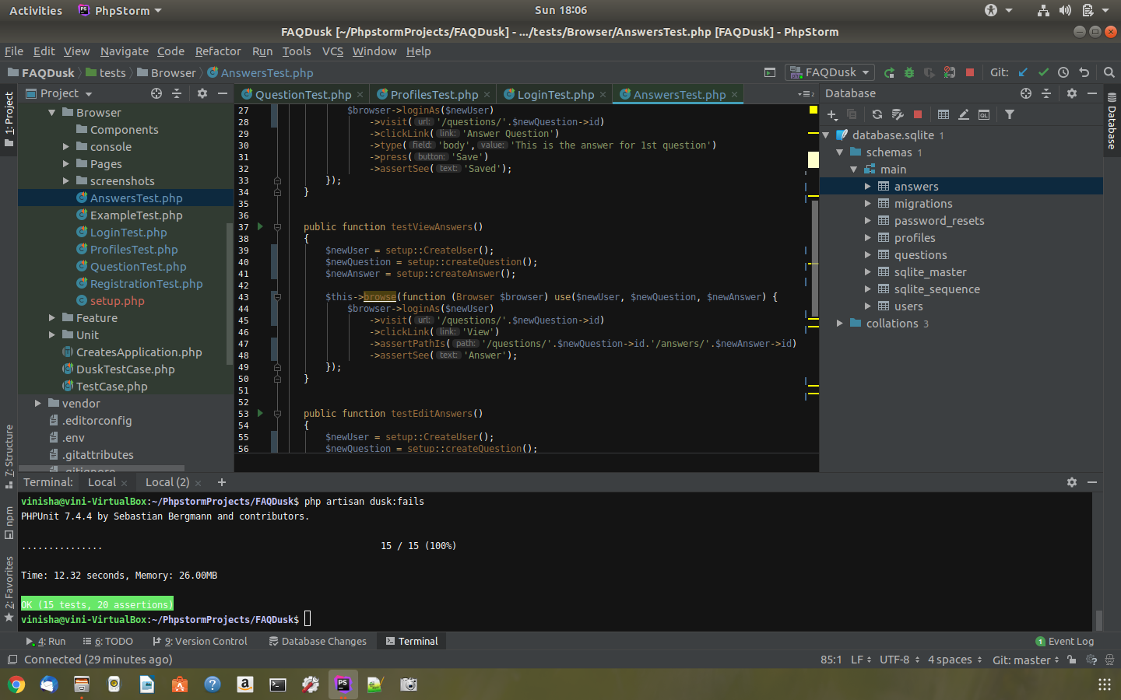

1. Test to edit answer:

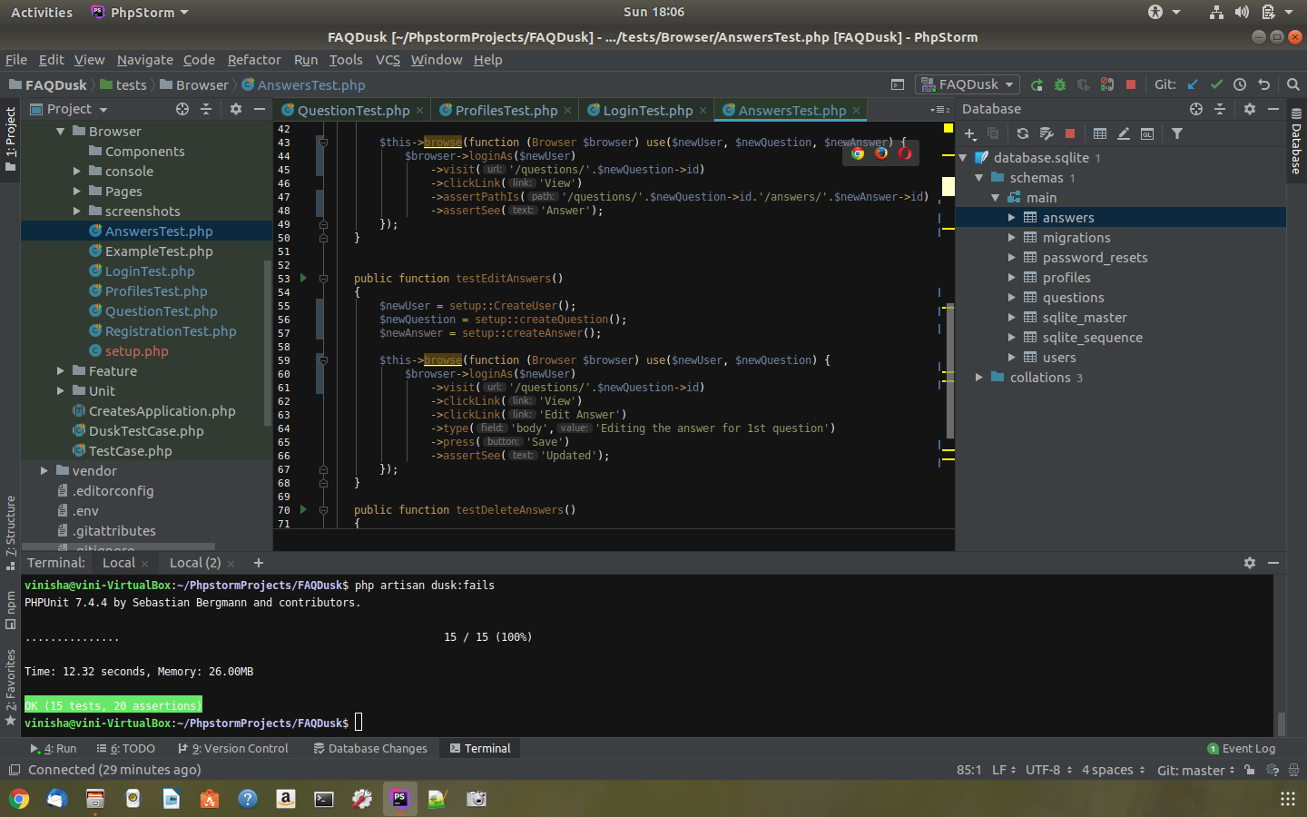

1. Test to Delete Answer:

